 | Project Design Phase-II
 | Technology Stack (Architecture & Stack)
Date |  | 16 October 2022
Team ID |  | PNT2022TMID24391
Project Name |  | Plasma Donor Application
Maximum Marks |  | 4 Marks

Technical Architecture:
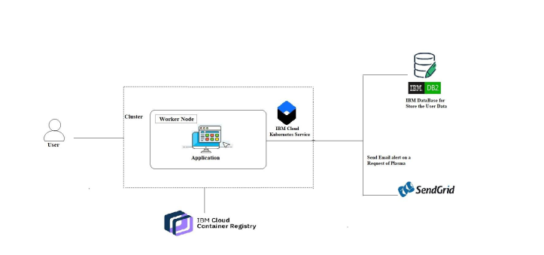
Table-1: Components & Technologies:

S. No | Component | Description | Technology
1. | Website | Donor can proceed the website to register and | HTML, CSS, JavaScript
 |  | patients can use them to post a request.
2. | Docker | Service for storing the private container images | Container Registry
3. | Kubernetes | Manage the complete process in the stable state | Kubernetes
 |  | If any software crash it automatically restart the work
4. | DB2 | Data types are String, Numeric, Date, time, and | MySQL
 |  | timestamp distinct types.
 |  | Act_ sortmem_ limit, auto_ del_ rec _ obj, auto_ maint
 |  | Configuration .
5. | Cloud DB2 | A fully managed cloud database with AI capabilities | IBM DB2
 |  | that keep our website running 24*7.
6. | SMTP Provider | Sends email alert on a request of plasma by the patients. | SendGrid
7. | Infrastructure (Server / Cloud) | Application Deployment on Local System / Cloud | Local, Cloud Foundry, Kubernetes, etc.
 |  | Local Server Configuration: Anaconda
 |  | Cloud Sever Configuration: IBM cloud
Table-2: Application Characteristics:
S. No | Characteristics | Description | Technology
1. | Open-Source Frameworks | Cloud Stack, Eucalyptus. | Docker
 |  | Open Nebula, App Scale, Docker.
2. | Security Implementations | Authentication and password management | Encryptions, Secured Authorization.
 |  | Accountability to authorize and monitor the use
 |  | anonymous accounts and to remove
3. | Scalable Architecture | To expand our server capacity, memory, or disc space | IBM DB2
4. | Availability | The administrator needs to look up the stock | Docker
 |  | availability in the database
5. | Performance | Speed up the webpage | Kubernetes
 |  | Site optimization based on data analysis.

